**Students**:

**Create a student**

* **Method**: POST
* **Endpoint**: /student
* **Request** **Body**:

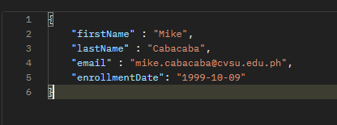

**Response**:

* **Status**: 201 Created
* 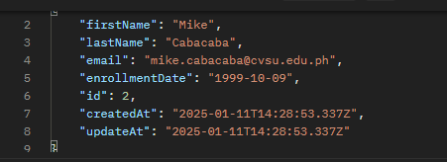**Body**:

**Get** **All** **Students**:

* **Method**: GET
* **Endpoint**: /students

**Response**:

* **Status**: 200 OK
* **Body**

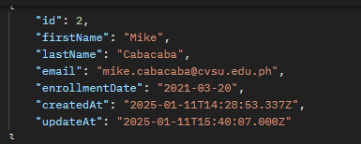

**Get a Single Student**

* Method: GET
* Endpoint: /students/3

**Response:**

* Status: 200 OK
* Body

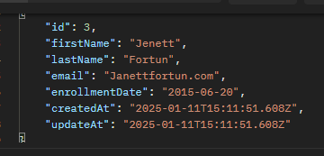

**DELETE**

Delete a student

* **Method**: DELETE
* **Endpoint**: /student/5
* **Request** **Body**:

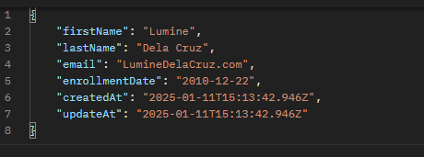

**UPDATE**

update a student

* **Method**: PUT
* **Endpoint**: /student/2
* **Request** **Body**:

